**Class:** Final Year (Computer Science and Engineering)

**Year:** 2024-25 **Semester:** 1

**Course:** High Performance Computing Lab

**Practical No. 4**

**Exam Seat No:21510043**

**name:shweta kakade**

**Title of practical:**

Study and Implementation of Synchronization

**Problem Statement 1:**

# Analyse and implement a Parallel code for below programs using OpenMP considering synchronization requirements. (Demonstrate the use of different clauses and constructs wherever applicable)

# Fibonacci Computation:

**Screenshots:**

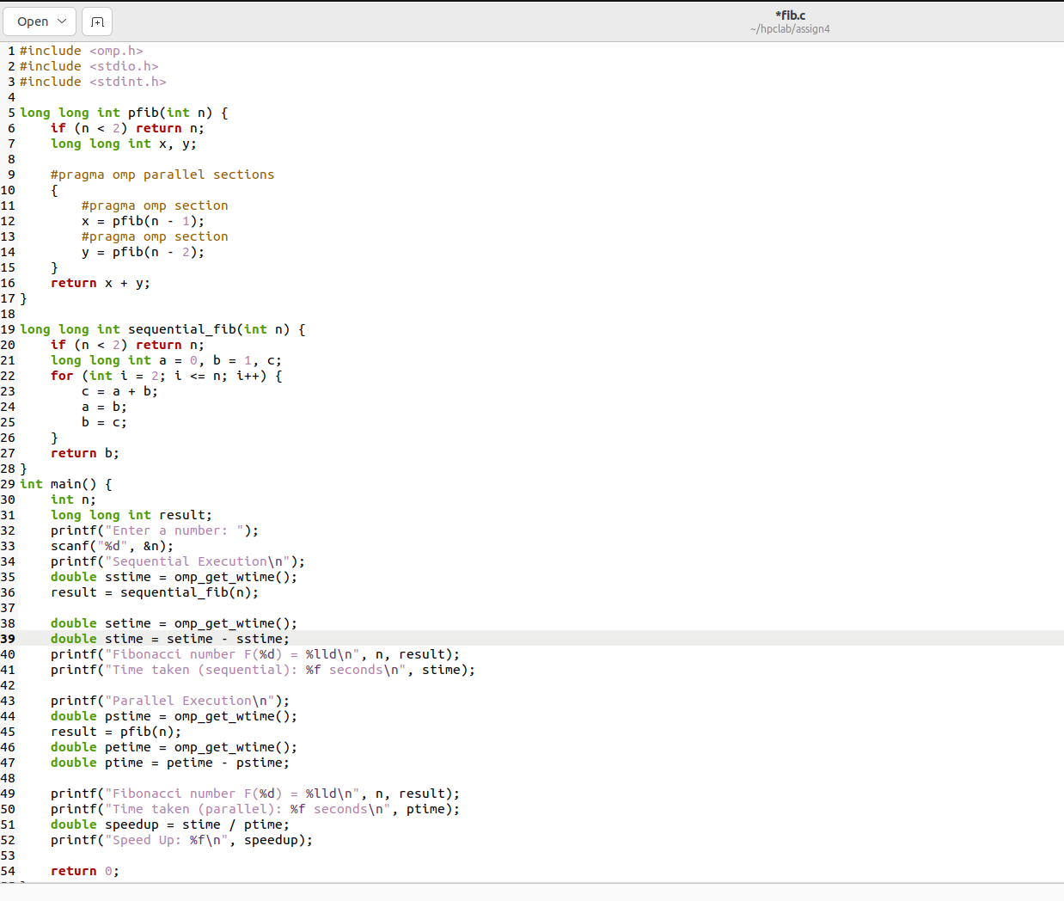

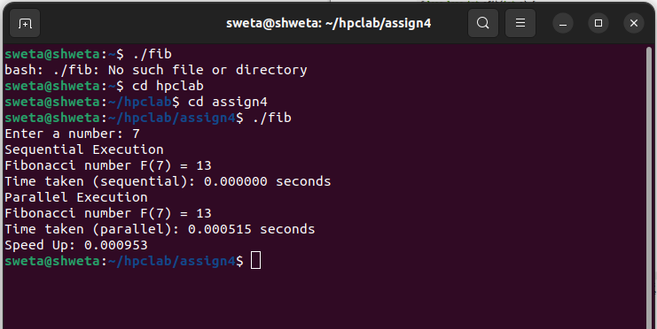

**Information:**

**sequential execution of fibonacci problem take long time as compared to parallel execution .**

**Problem Statement 2:**

# Analyse and implement a Parallel code for below programs using OpenMP considering synchronization requirements. (Demonstrate the use of different clauses and constructs wherever applicable)

## Producer Consumer Problem

**Screenshots:**

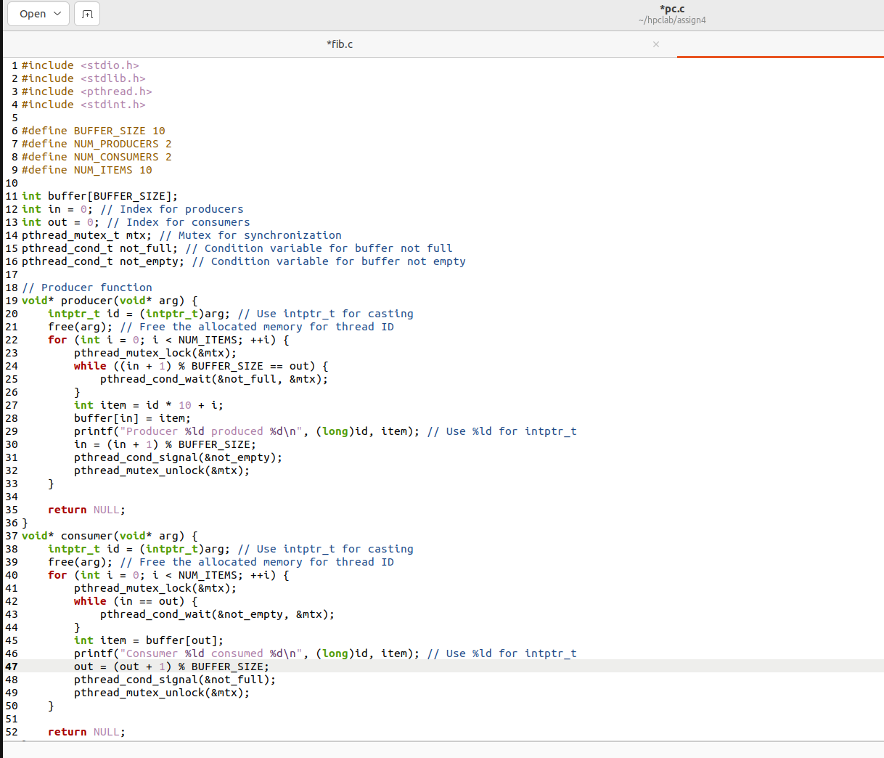

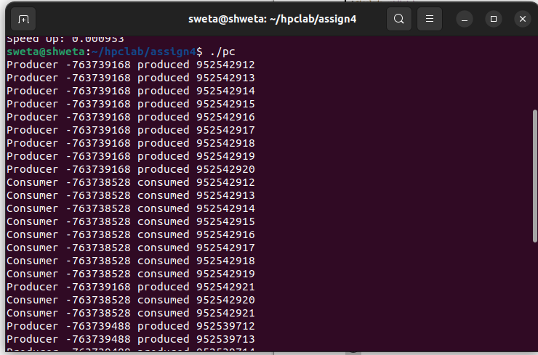

**Information:**

**this probram implements producer consumer problem with synchronization.**

**Github Link:**

**https://github.com/shweta29k/HPC_LAB**